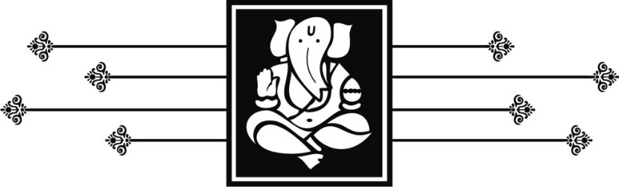
For having blessed our lives
with the joy of knowing you
We
Umesh & Chaitra Shetty
Request your ardent prayers and presence with family
as you share our happiness in celebrating the
marriage of our Sweet Daughter
Ashwi
with
Aarush
(S/o. Mr. Satyaraj Shetty & Mrs. Shobha Shetty)
On Monday 21st May 2018
LOGOS/SYMBOLS IN THE DOCUMENT CAN BE CHANGED (IF REQUIRED) TO THE LOGOS/SYMBOLS CHOSEN FROM OUR LIBRARY. CLICK HERE TO BROWSE OUR LIBRARY OF LOGOS/SYMBOLS.

Programme
On Sunday 20th May 2018
Haldi & Mehendi : 6.30 pm to 9.30 pm
At our Residence
On Monday 21st May 2018
Wedding Muhuratham : 11.45 am
followed by Lunch
On Wednesday 21st May 2018
Reception : 7.00pm to 10.00
followed by Dinner & Cocktails
Venue
ITC Maratha
Luxury Collection Hotel, Sahar Road,
Opposite Chhatrapati Shivaji Airport,
Andheri East, Mumbai - 400099
~No Gifts Blessings Only~
LOGOS/SYMBOLS IN THE DOCUMENT CAN BE CHANGED (IF REQUIRED) TO THE LOGOS/SYMBOLS CHOSEN FROM OUR LIBRARY. CLICK HERE TO BROWSE OUR LIBRARY OF LOGOS/SYMBOLS.

